Manger node ------------

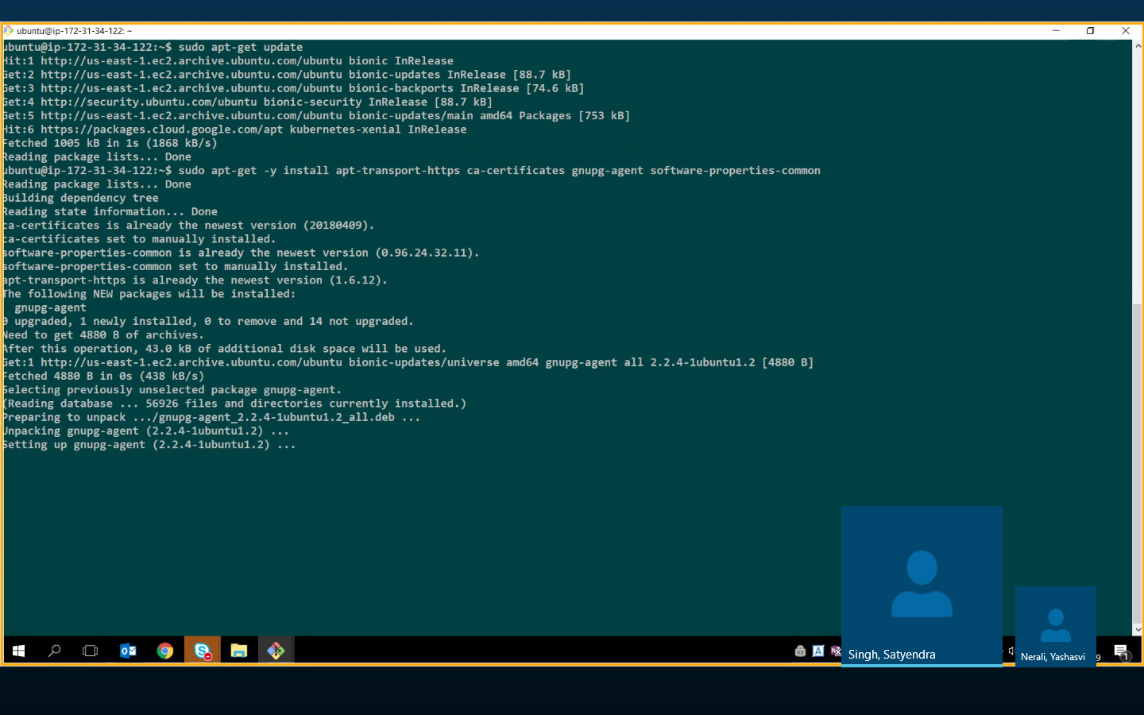

**Add gpg key**

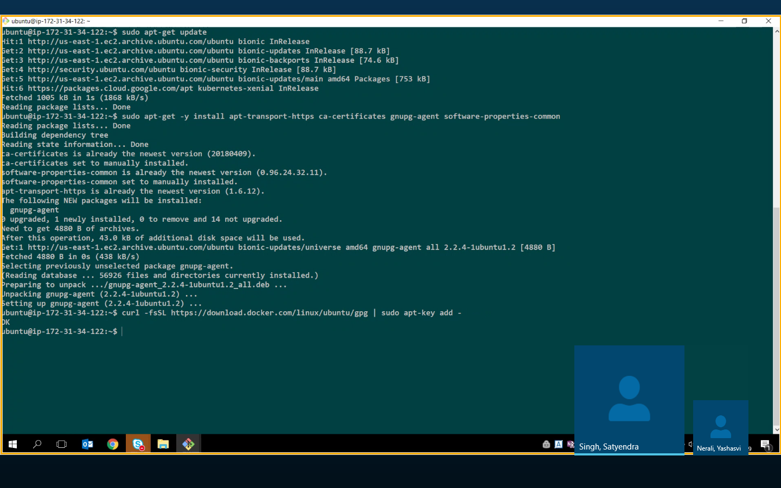

**Fingerprint add**

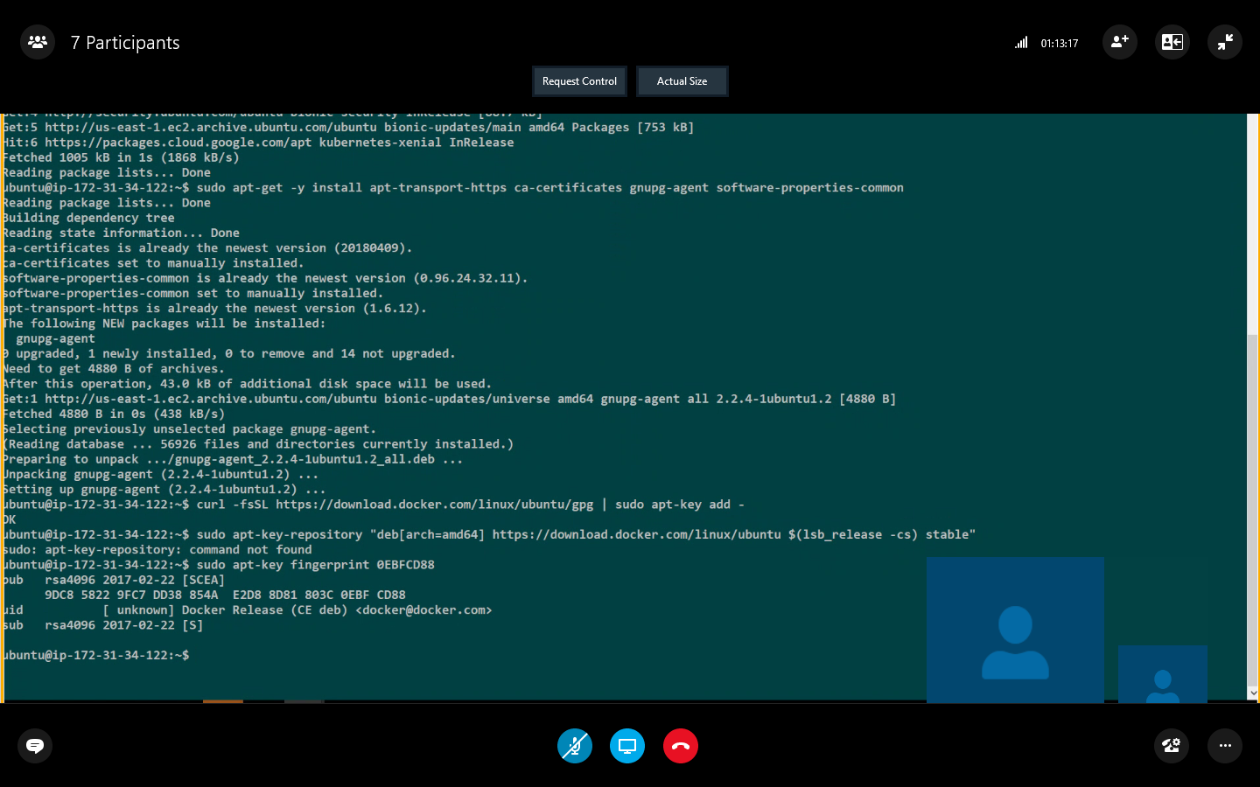

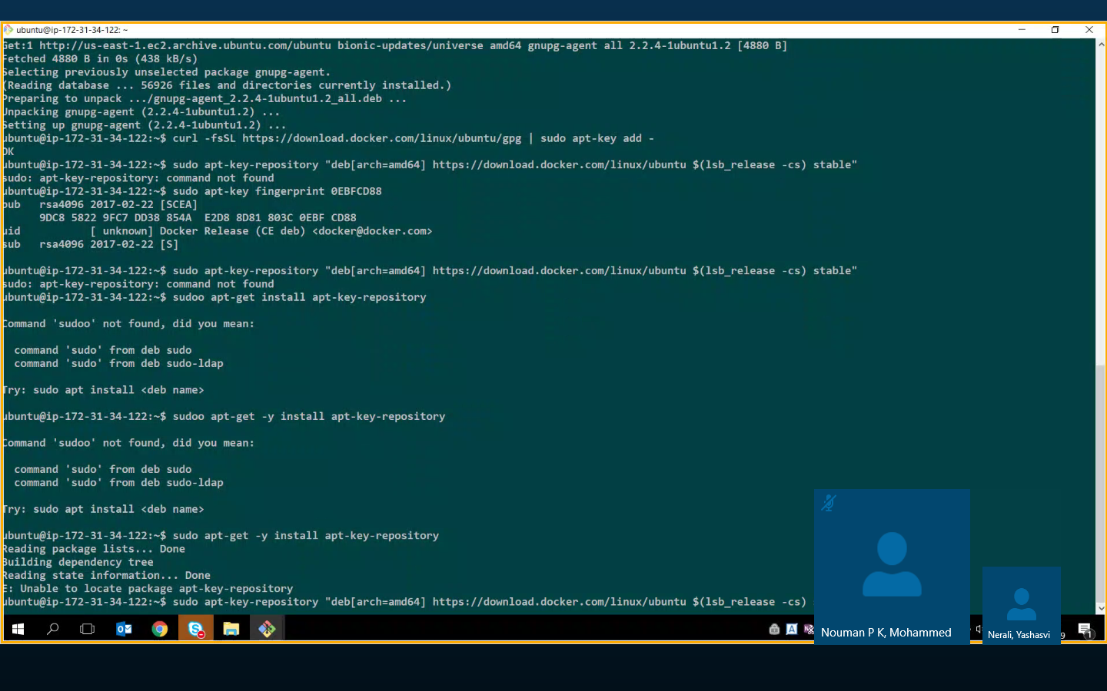

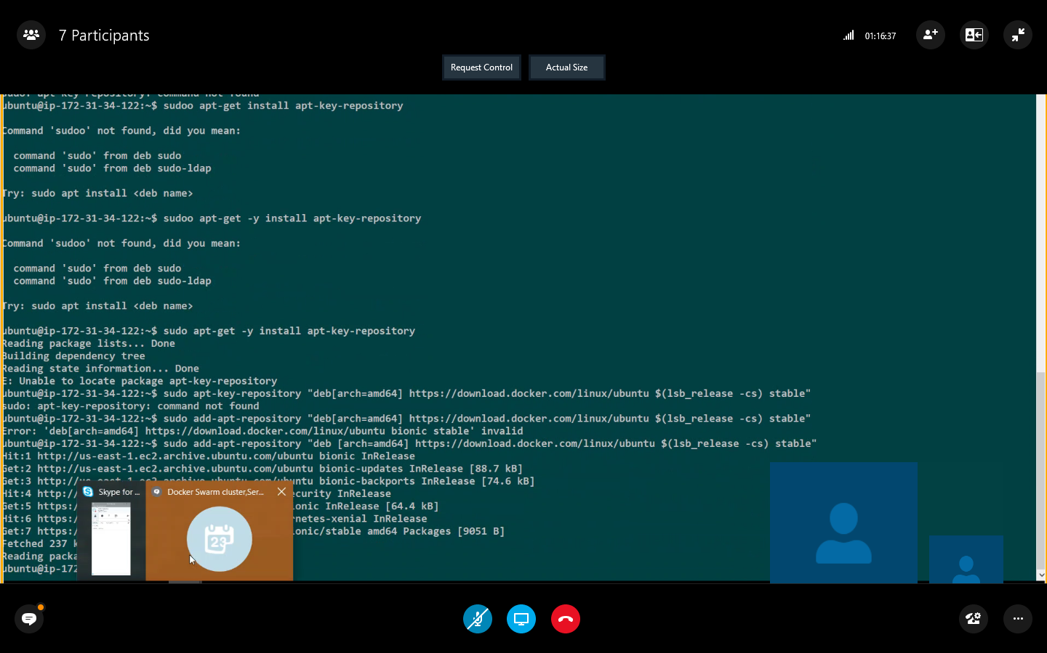

**Sudo apt-get update**

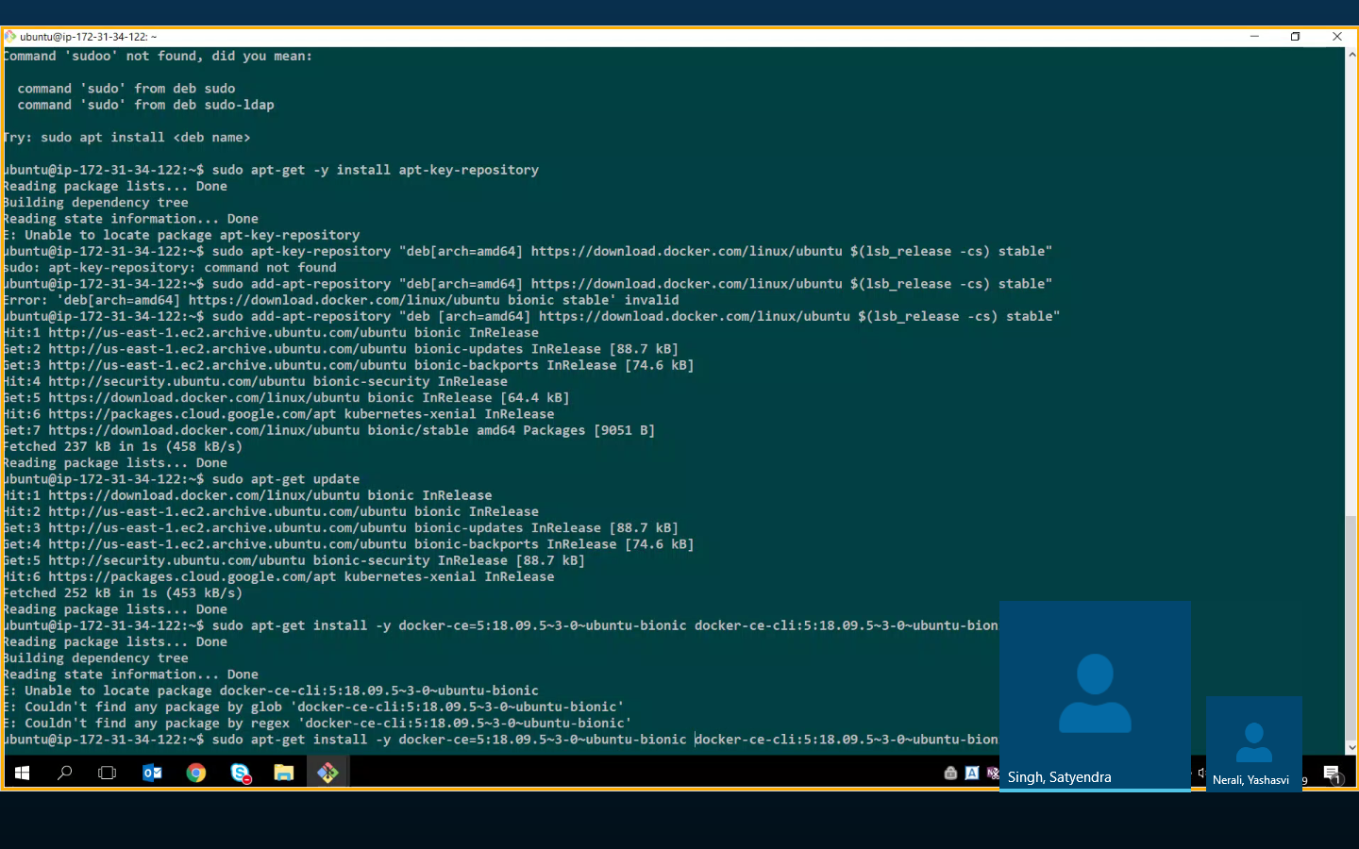

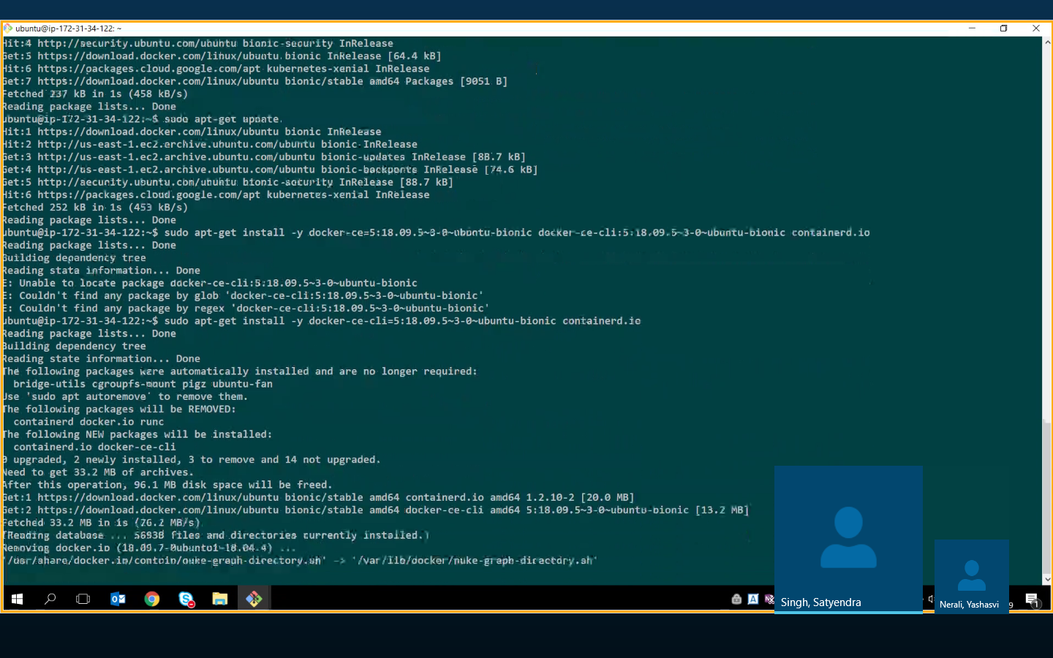

**When initial & joining network use private ip add**

**Check command init & join-do it**

**Lock swarm for security & need to restart to work**

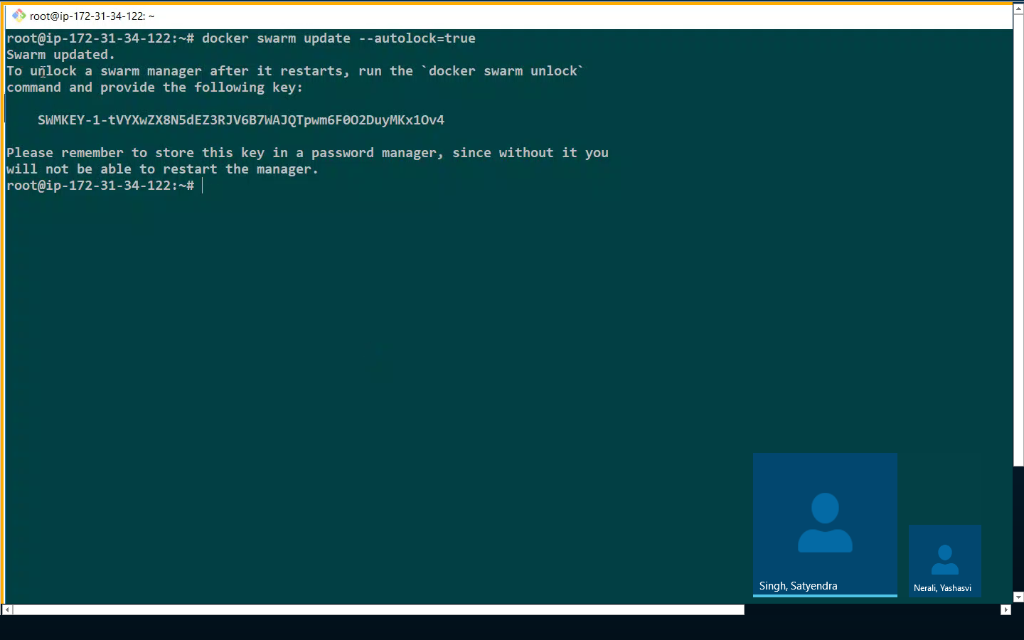

**Not key if req to unlock**

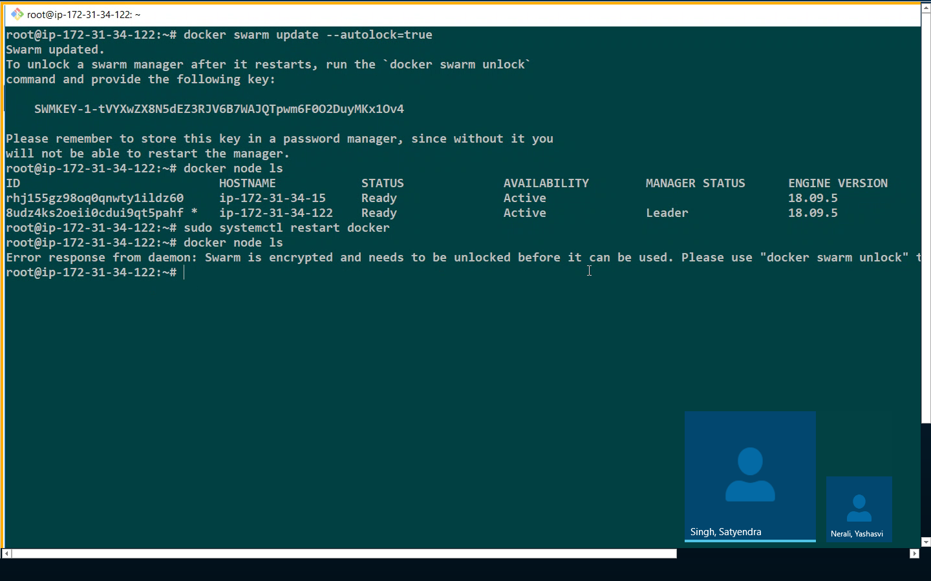

**Docker swarm admin guide learnmajority=no of node/2 +1 ### +1 is manager**

**Anything more than 3 is a fault tolerance**

**Min 3 nodes are req & min 3 manager 7 max 7 manager nodes to avoid cond of manager goes down**

**SERVICES-**

**To deploy application image**

**Create docker service which runs nginx**

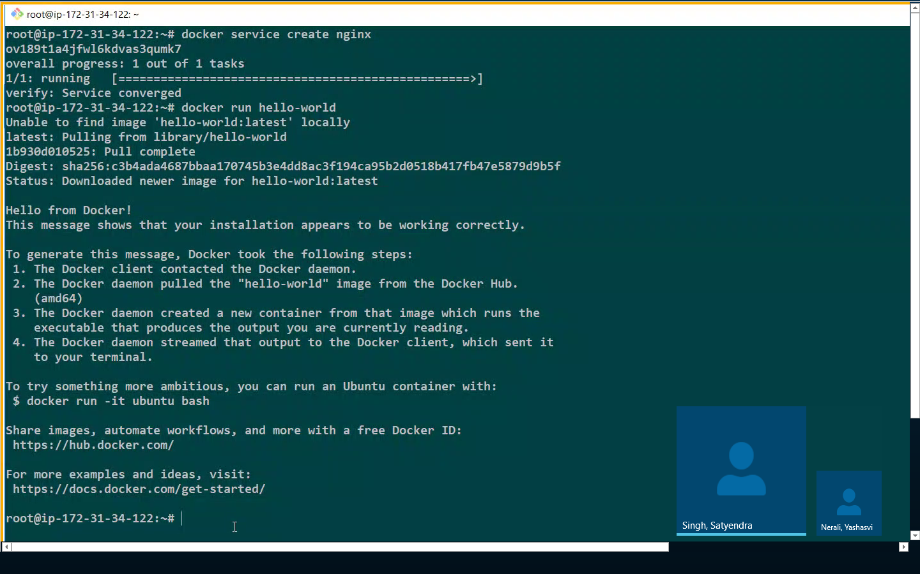

**Above—with Service its advantage to create replicas & high availability which not possible in docker run comman.**

**Docker service ls to check services**

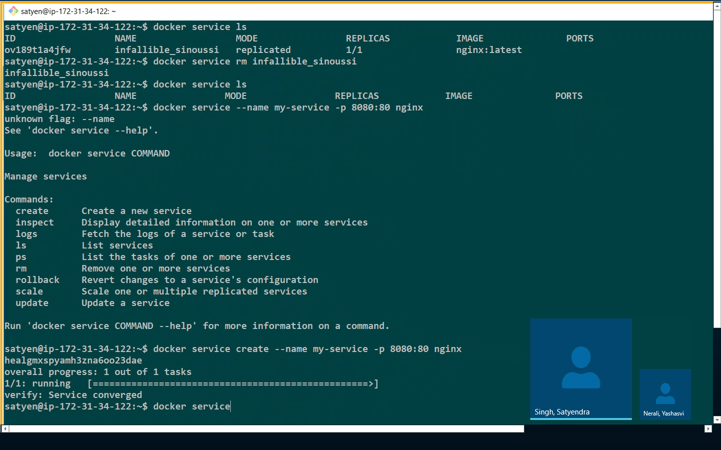

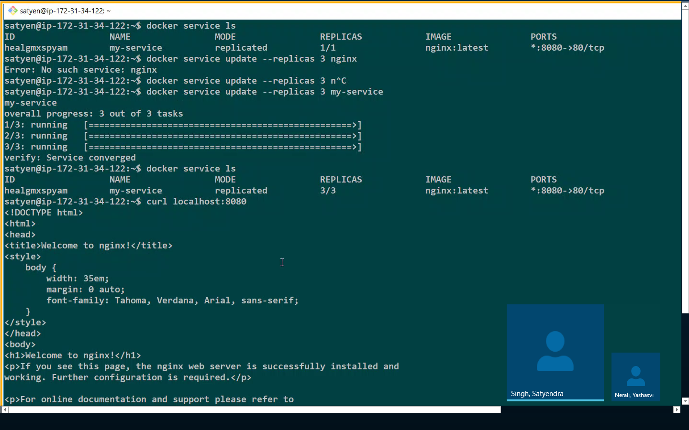

**Or**

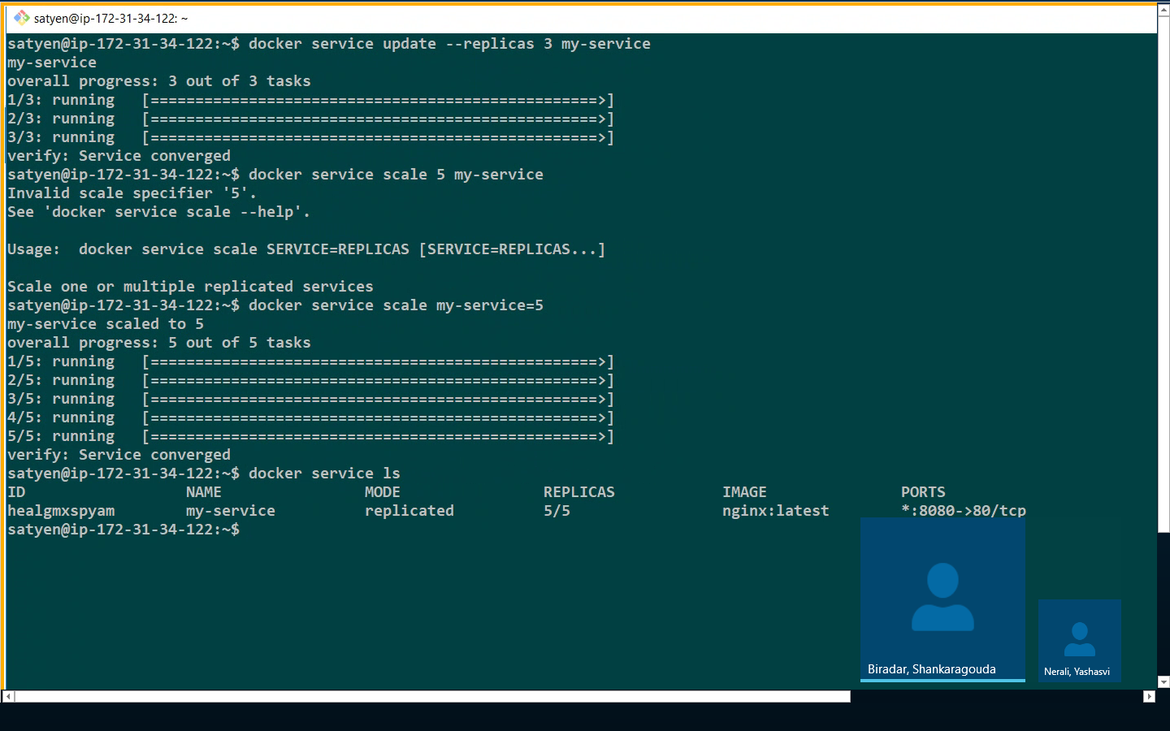

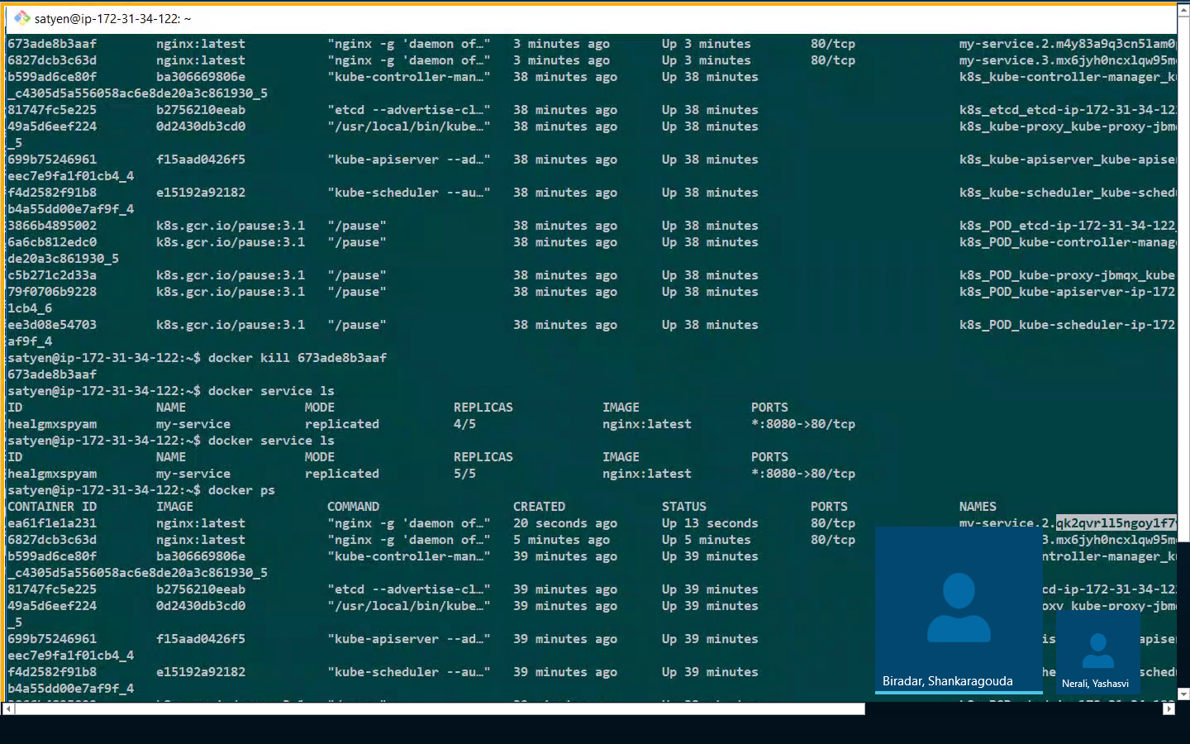

**Docker service inspect servicenamme**

**Or**

**Docker service inspect pretty servicename**

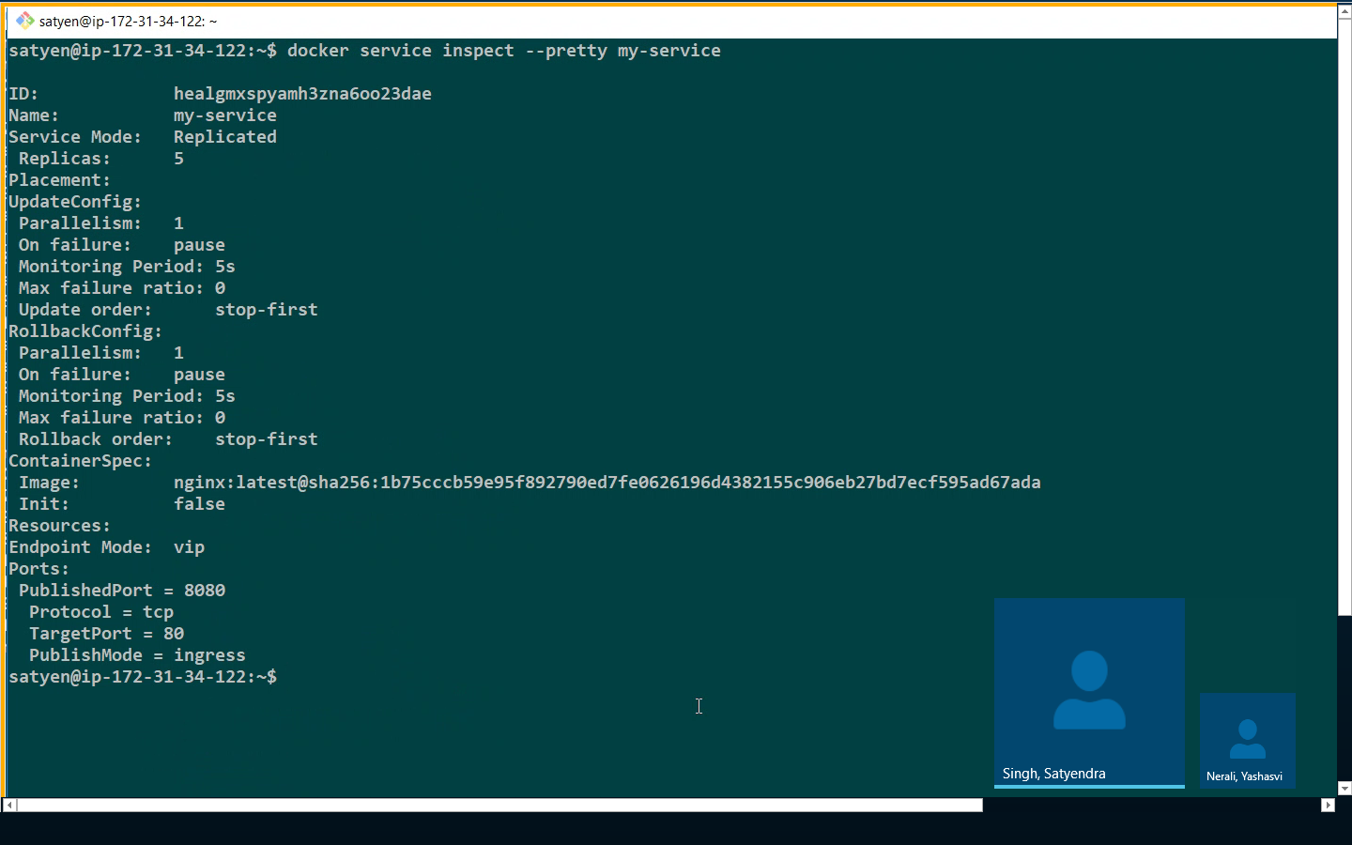

**Labels in docker inspect helps to filter –same fo all containers**

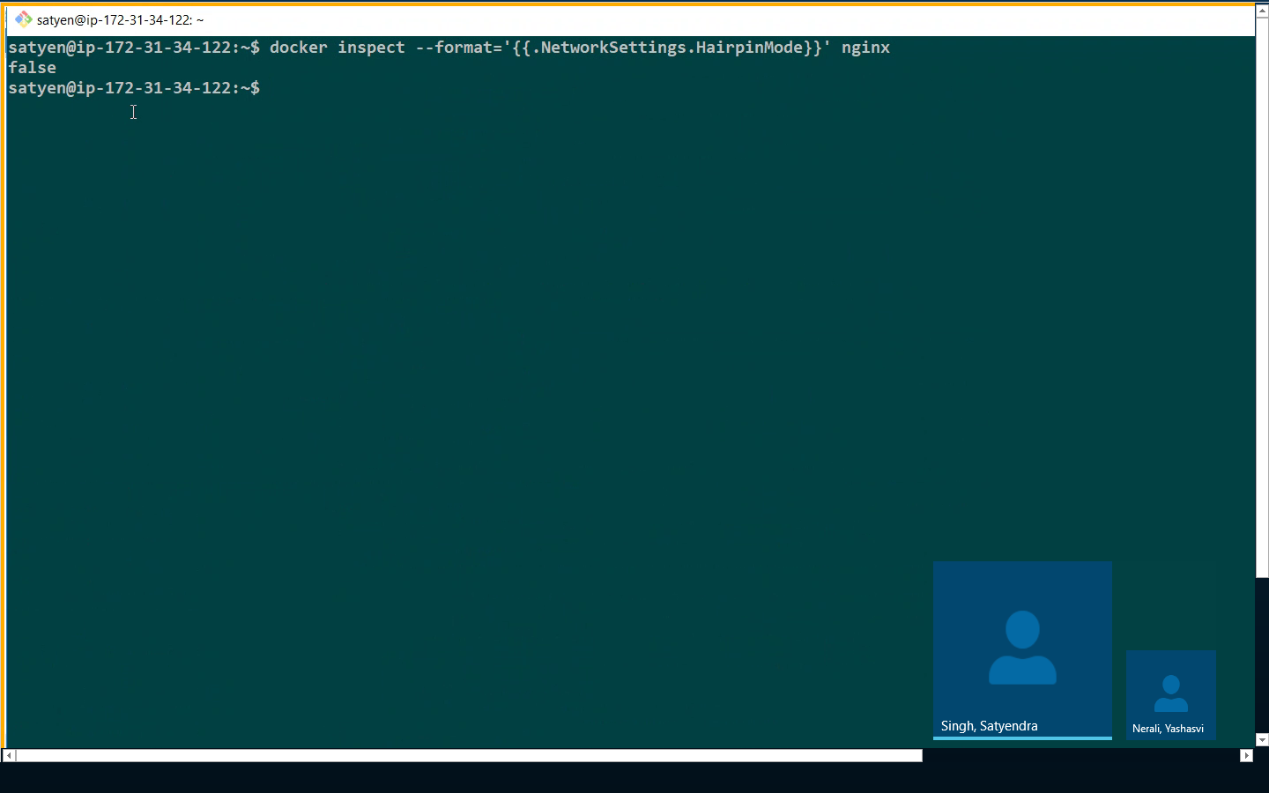

**Docker compose—service (with all replica containers)**

**Communicate with each other**

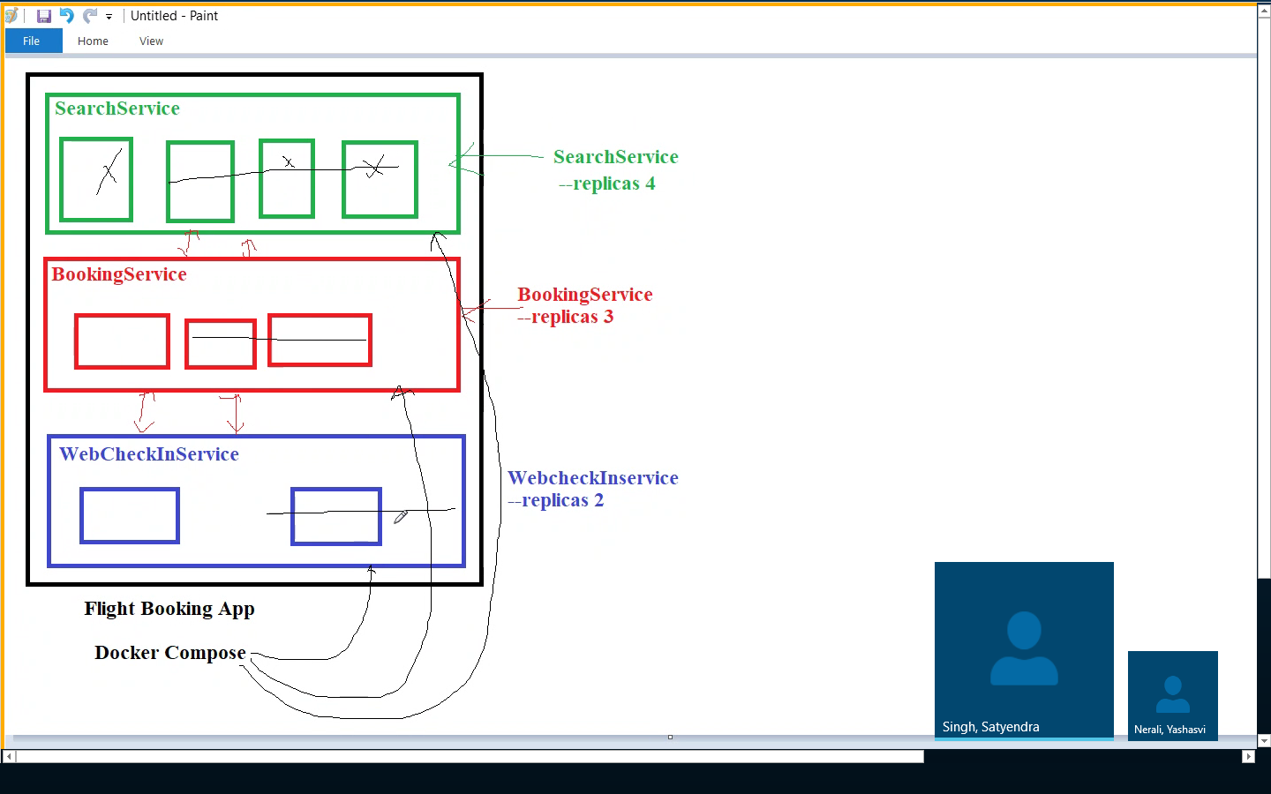

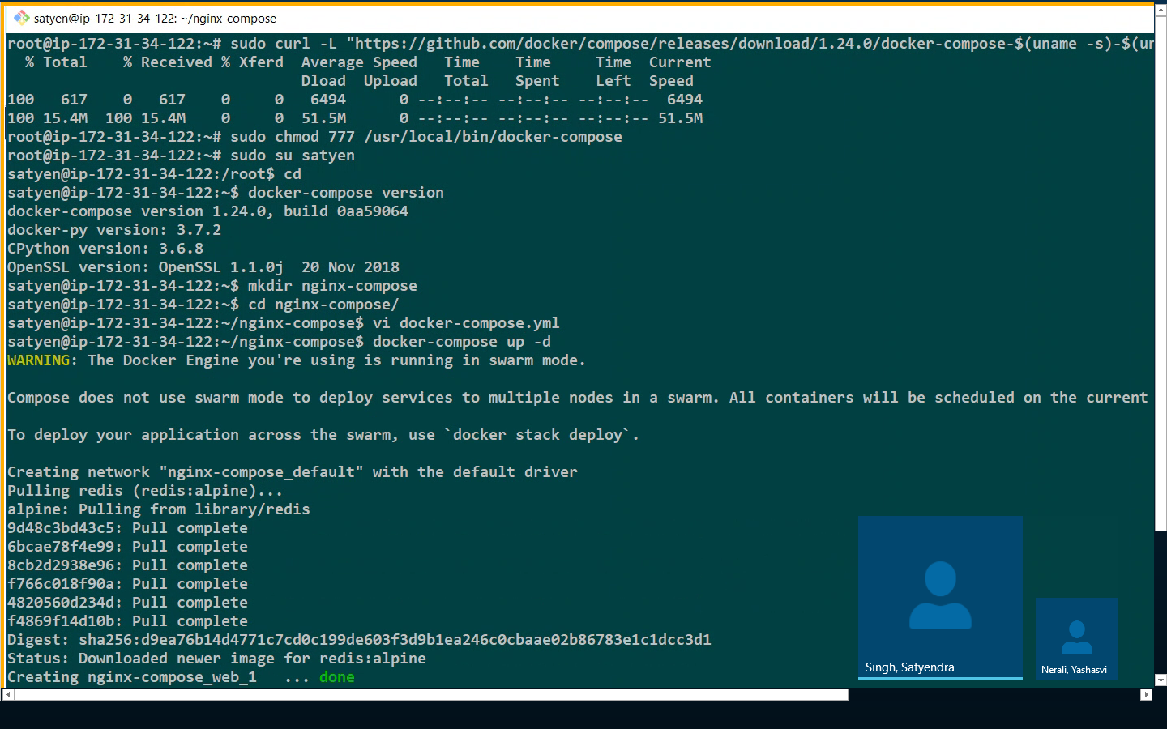

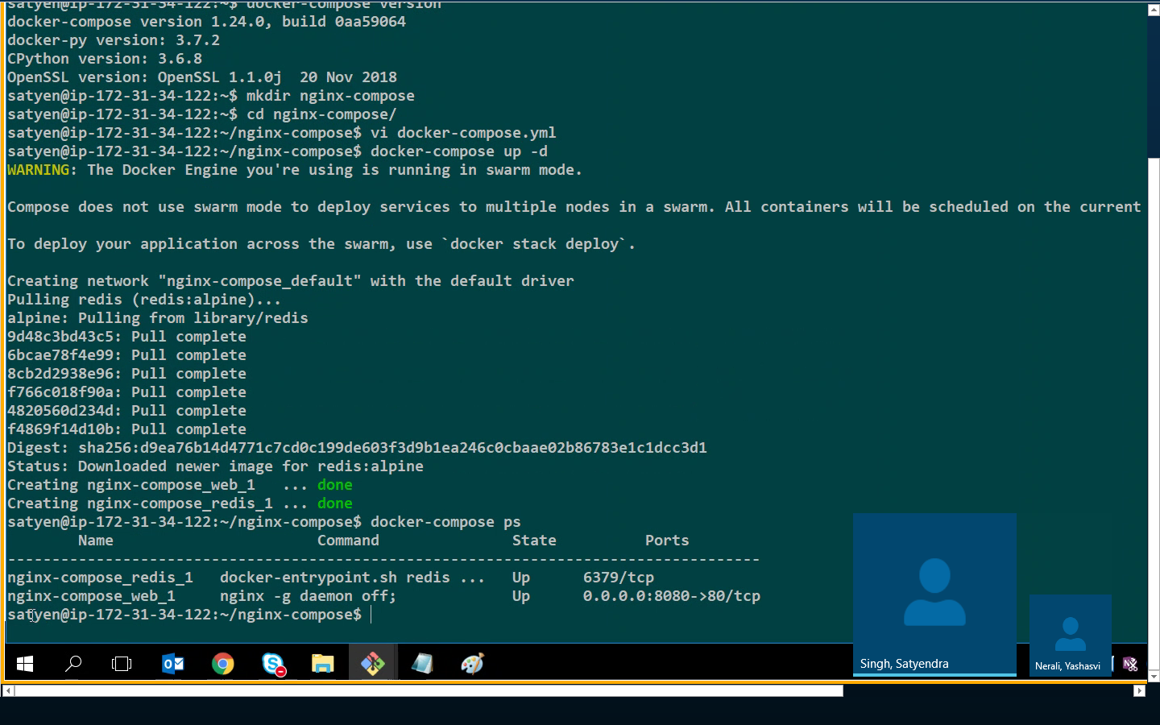

**Docker-compose down to stop**

**DOCKER STACK=============**

**Manage complex multicontainer application within docker swarm**

**vi simple-stack.yml**

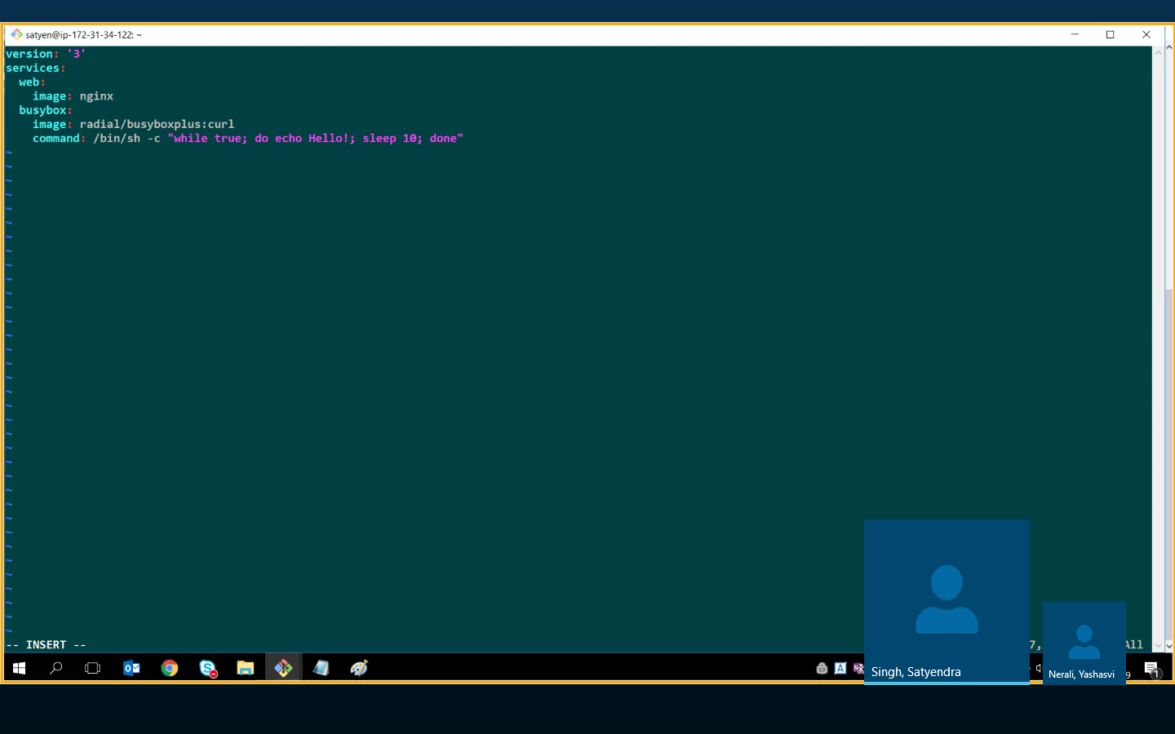

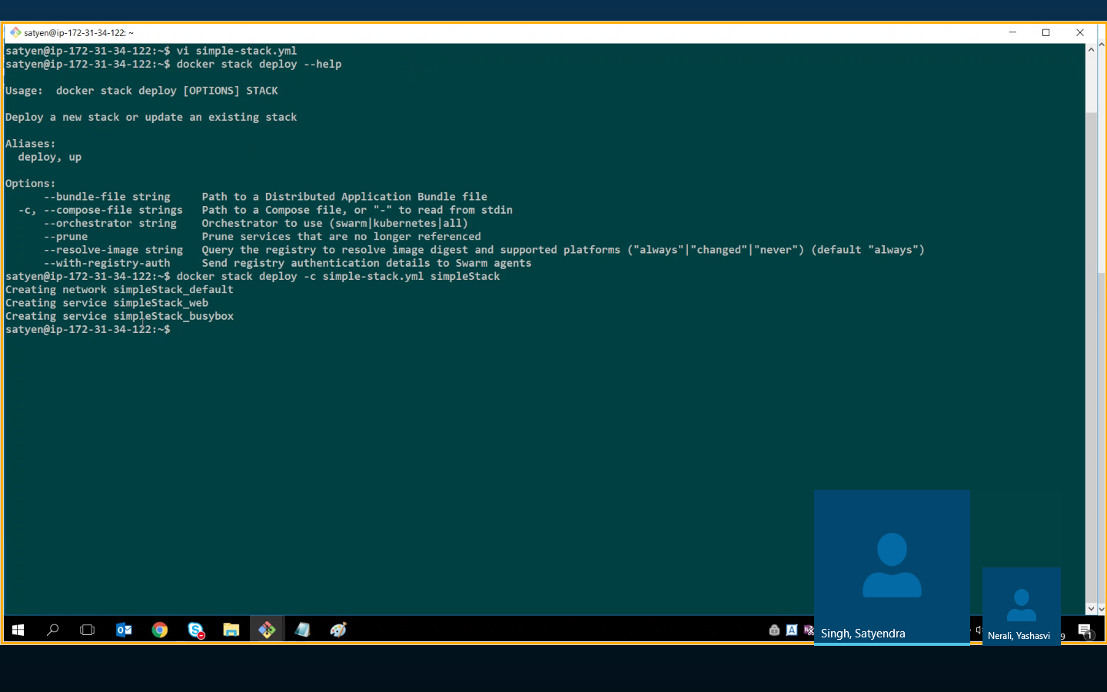

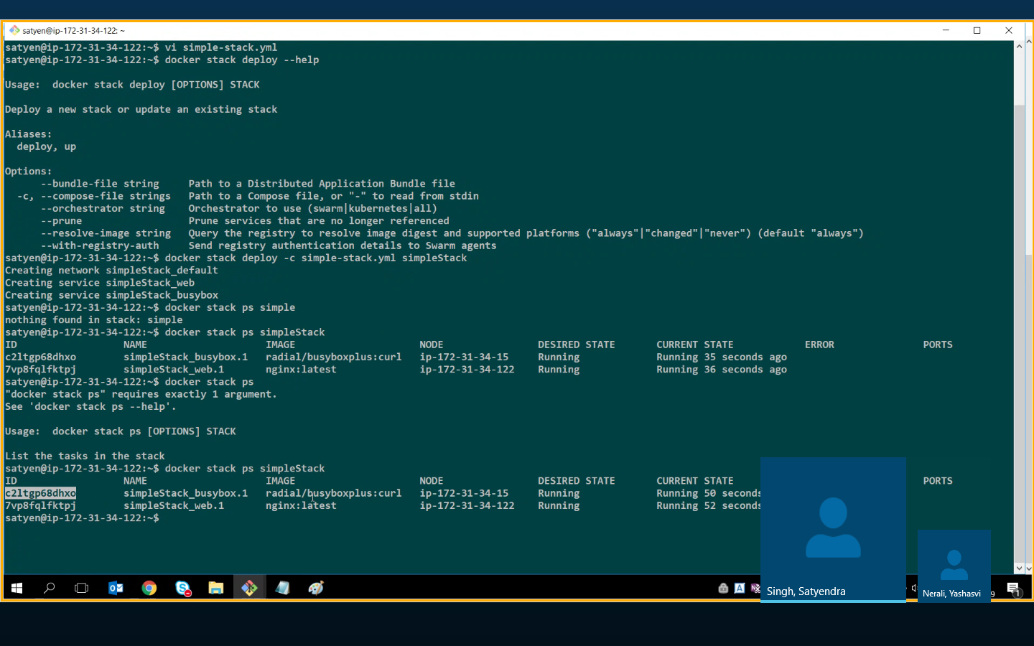

**Edit stack file**

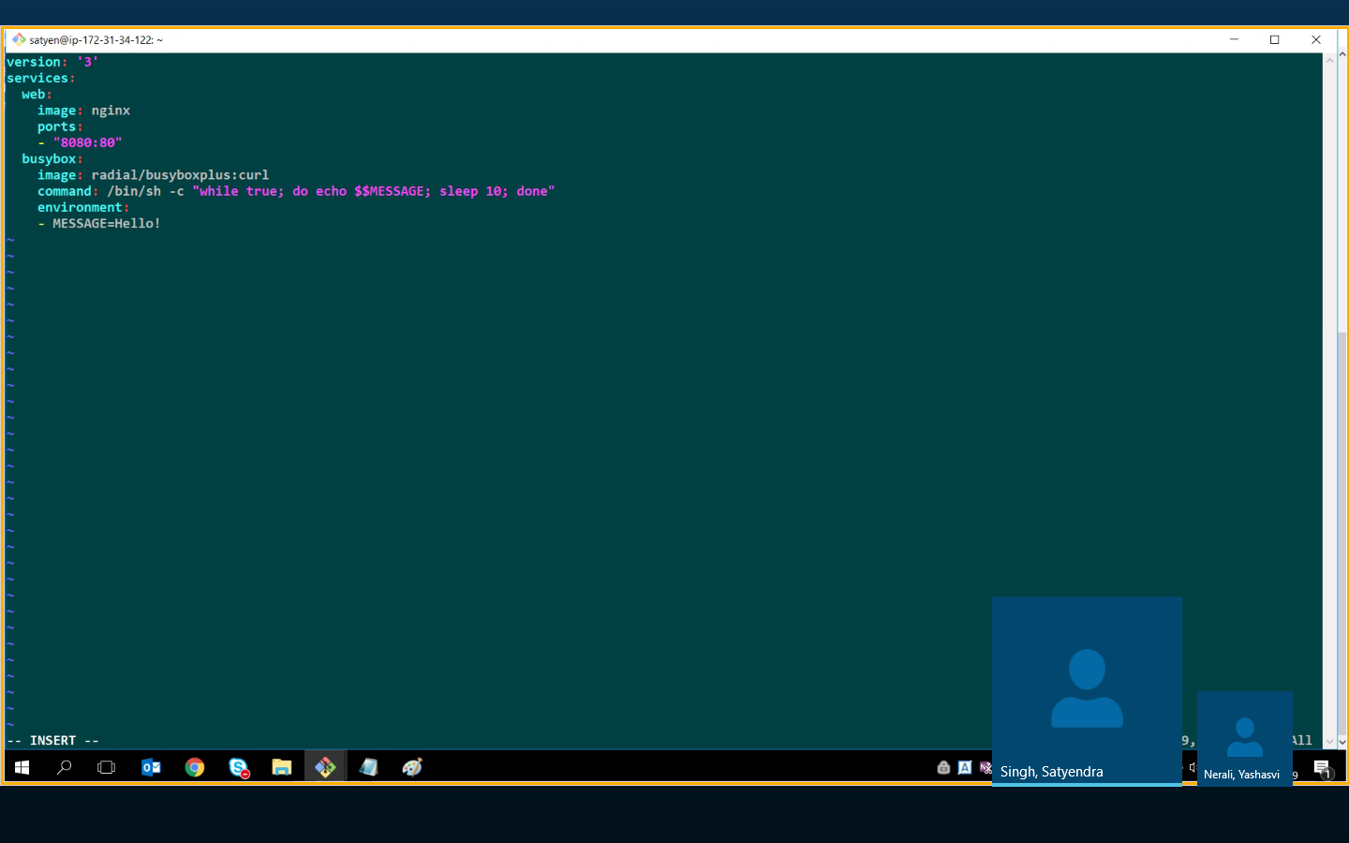

**Change port to 8086 O else**

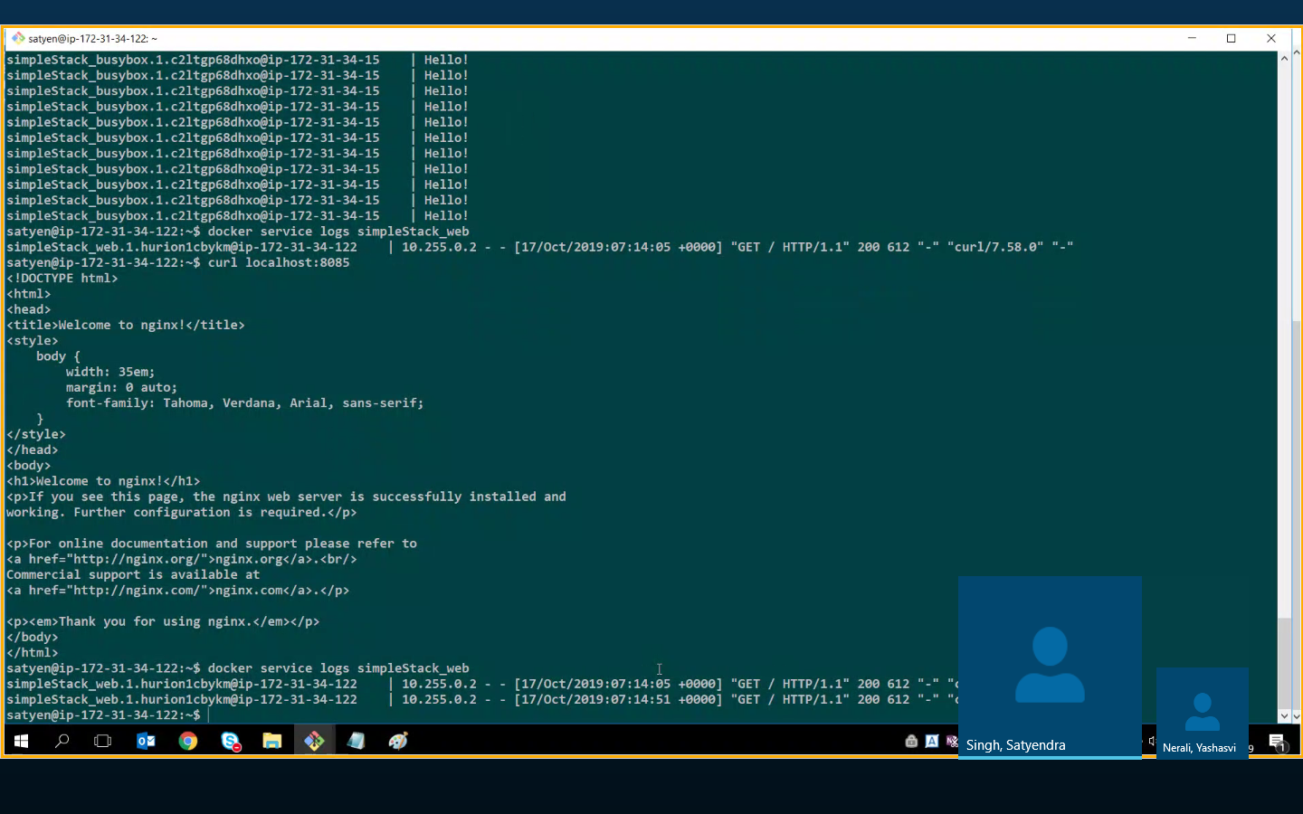

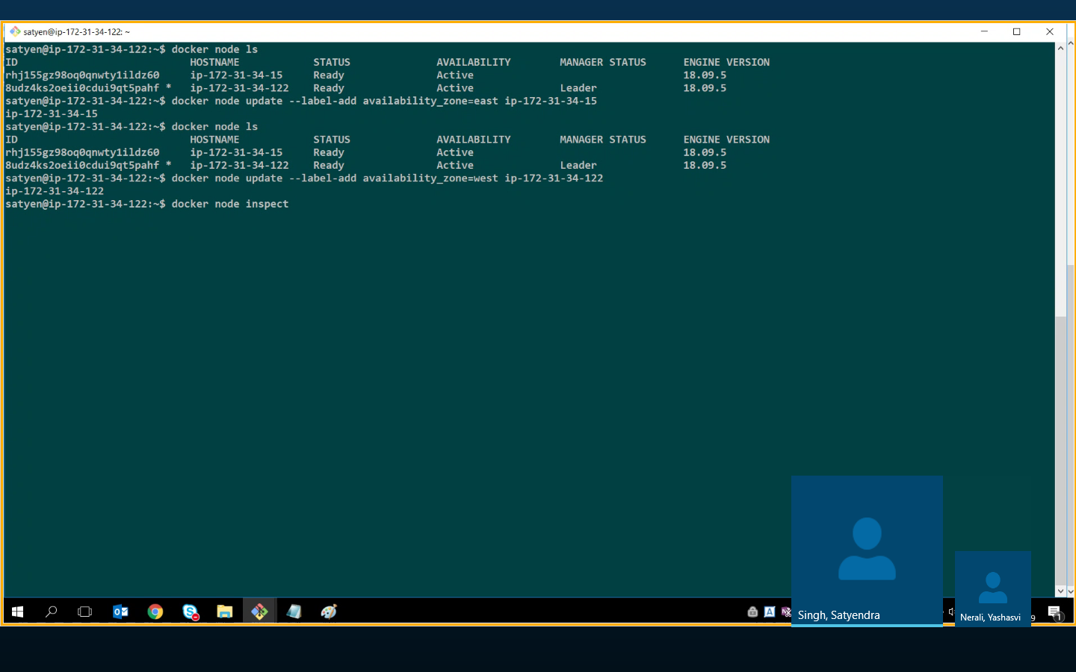

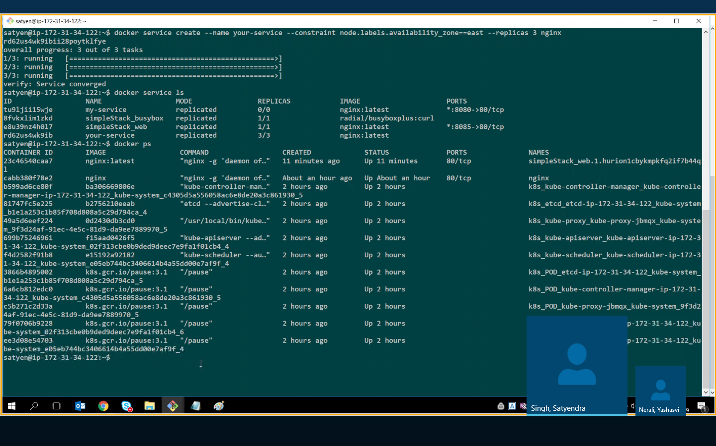

**Docker**

docker swarm init --advertise-addr myipaddress

